C.V
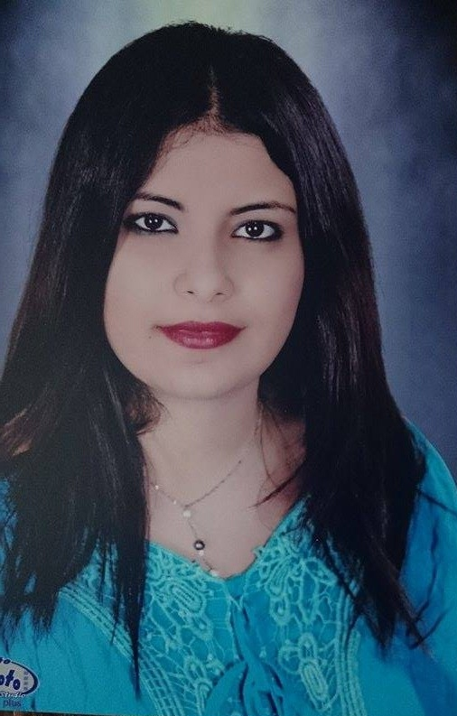
Name: Engy Ahraf Girgis Abd-elmalak

Adress: 24 el nasr ST. Taqseem El-petrol

Education: Bachelor of Commerce (Accounting section)
Job: Demonstrator at Faculty of Commerce (Accounting section) ,English departmrnt, Assuit university

